Diet and Cancer (Part 1): How Nutrition Shapes Tumor Metabolism

Dietary Interventions In Cancer
Cancer & Metabolic Healing
Mar 17, 2026

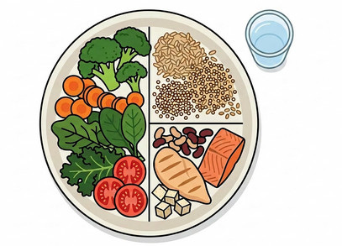

One of the first questions many people ask their oncologist following a cancer diagnosis is deceptively simple: “What should I eat?”
And all too often, the answer they hear is: “It doesn’t matter. Eat whatever you like—cake, ice cream, chocolate if it makes you happy.”
Yet that response reflects a deep misunderstanding. Food isn’t just comfort or calories, it’s chemistry, information, and energy. Every bite sends molecular messages that can fuel disease or fight it. In truth, dietary choices are not secondary to cancer therapy; they are foundational.
Cancer does not exist in isolation. It thrives within the biological environment it’s given, and that environment is shaped daily by what we eat, how we move, and the rhythms we keep. The right nutrition can shift that terrain—undermining cancer’s metabolic advantages while strengthening healthy cells and immune defenses. This isn’t fringe thinking or “alternative” care; it’s physiology, long overlooked in standard oncology.
When we speak of dietary interventions, we’re referring not merely to “healthy eating,” but to targeted nutritional strategies that modify cancer metabolism itself. Low-glycemic and ketogenic diets reduce glucose availability and calm insulin signaling—pathways central to many tumors’ growth advantage. Fasting and fasting-mimicking regimens, meanwhile, activate protective stress responses that sensitize cancer cells to treatment while shielding normal tissue.
These strategies are increasingly supported by evidence, highlighting a profound truth: the body’s metabolism is not just a passive background for disease, but an active system that can be guided, redirected, and optimized. Harnessing that system through intentional nutrition may be one of the most important shifts in how we approach cancer in the modern era. - Paul.

Numerous studies show that dietary energy restriction is a general metabolic therapy that naturally lowers circulating glucose and insulin levels and significantly reduces the growth and progression of numerous tumor types, including cancers of the breast, brain, colon, pancreas, lung, and prostate. (1-7) An impressive body of evidence indicates that dietary energy restriction can retard the growth rate of many tumors regardless of the specific genetic defects expressed within the tumor. (1-7) Hyperglycemia with high insulin levels is associated with tumor recurrence. (8, 9) Sugar sweetened beverages are associated with an increased risk of cancer. (10-12) Both experimental and clinical data suggest that fructose, particularly fructose-corn syrup, to be more carcinogenic than glucose. (13-16)
As demonstrated by Dr. Otto Warburg, almost all cancer cells are dependent on glucose as a metabolic fuel via aerobic glycolysis, (17, 18) with hyperglycemia being a potent promotor of tumor cell proliferation and associated with poor survival. (19) Although the mechanisms responsible for the caloric-restriction-mediated reduction in tumorigenesis have not been unequivocally identified, they may involve caloric-restriction-induced epigenetic changes as well as changes in growth signals and in the sirtuin pathway. (20)
Insulin resistance plays a major role in the initiation and propagation of cancer. (21) Reversing insulin resistance is therefore a major goal in patients with cancer. Dietary energy restriction specifically targets the IGF-1/PI3K/Akt/HIF-1α signaling pathway, which underlies several cancer hallmarks including cell proliferation, evasion of apoptosis, and angiogenesis. IGF-1 production is stimulated by growth hormone (GH) and can be inhibited by calorie restriction, suggesting it could play a central role in the protective effect of calorie restriction. In this regard, humans with mutations in the GH receptor (known as Laron syndrome) have low serum IGF-1 levels, and have a remarkably low risk of developing cancer. (20) Glucose reduction not only reduces insulin but also reduces circulating levels of IGF-1, which is necessary for driving tumor cell metabolism and growth. In diabetics, those on insulin or insulin secretagogues were demonstrated to be more likely to develop solid cancers than those on metformin. (22)
Dietary energy restriction targets inflammation and the signaling pathways involved with driving tumor angiogenesis. Indeed, calorie restriction is considered a simple and effective therapy for targeting tumor angiogenesis and inflammation. Calorie restriction results in the downregulation of multiple genes and metabolic pathways regulating glycolysis. Besides lowering circulating glucose levels, dietary energy restriction elevates circulating levels of fatty acids and ketone bodies (β-hydroxybutyrate and acetoacetate). Fats, and especially ketones, can replace glucose as a primary metabolic fuel under calorie restriction. This is a conserved physiological adaptation that evolved to spare protein during periods of starvation. Many tumors, however, have abnormalities in the genes and enzymes needed to metabolize ketone bodies for energy. Elevation in ketone bodies is well known to be able to suppress blood glucose levels and glycolysis, which are major drivers of tumor growth. A transition from carbohydrates to ketones for energy is a simple way to target energy metabolism in glycolysis-dependent tumor cells while enhancing the metabolic efficiency of normal cells. Metabolism of ketone bodies and fatty acids for energy requires inner mitochondrial membrane integrity and efficient respiration, which tumor cells largely lack. Under fasting conditions, ketone bodies are produced in the liver from fatty acids as the main source of brain energy. Ketone bodies bypass the glycolytic pathway in the cytoplasm and are metabolized directly to acetyl CoA in the mitochondria.
The ketogenic diet is a high-fat, low-carbohydrate diet with adequate protein and calories originally developed in the 1920s as a treatment for intractable epilepsy.(23) The traditional ketogenic diet is a 4:1 formulation of fat content to carbohydrate plus protein. (23) A classic 4:1 ketogenic diet delivers 90% of its calories from fat, 8% from protein and only 2% from carbohydrate. Ketogenic diets of the 1920s and 1930s were extremely bland and restrictive diets and, therefore, prone to noncompliance. In recent years, alternative keto-genic protocols have emerged, making adherence to the diet much easier.(24) Alternatives to the traditional keto-genic diet include a medium-chain triglyceride (MCT)-based ketogenic diet and the Akins diet. Compared to long-chain triglycerides, MCTs are more rapidly absorbed into the bloodstream and oxidized for energy because of their ability to passively diffuse through membranes. Another characteristic of MCTs is their unique ability to promote ketone body synthesis in the liver. Thus, adding MCTs to a ketogenic diet would allow significantly more carbohydrates to be included. (24)
Figure 1. Effect of a ketogenic diet and normal and cancer cells.

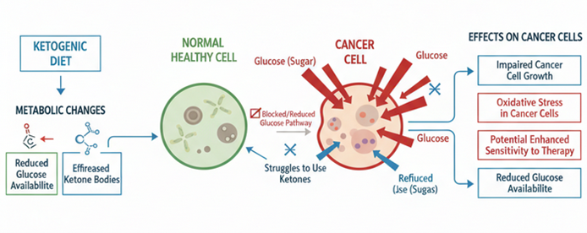

A ketogenic diet has tumor growth-limiting effects, protects healthy cells from damage by chemotherapy or radiation, accelerates chemotherapeutic toxicity toward cancer cells, and lowers inflammation. (24) Altered availability of glucose and induction of ketosis influence all the classically defined hallmarks of cancer.(25) Weber et al demonstrated that ketogenic diets slow melanoma growth in vivo regardless of tumor genetics and metabolic plasticity. (26) Moreover, ketogenic diets simultaneously affected multiple metabolic pathways to create an unfavorable environment for melanoma cell proliferation. In glioma cancer models a ketogenic diet has been shown to reduce angiogenesis, inflammation, peri-tumoral edema, migration and invasion. (27) Similarly, a ketogenic diet altered the hypoxic response and affects expression of proteins associated with angiogenesis, invasive potential and vascular permeability in a mouse glioma model. (28) The ketogenic diet may work in part as an immune adjuvant, boosting tumor-reactive immune responses in the microenvironment by alleviating immune suppression.(29) A meta-analysis on the use of ketogenic diet in animal models demonstrated significantly prolonged survival time and reduced tumor weight and tumor volume. (30) The ketogenic diet was effective across a broad range of cancers. The ketogenic diet is an effective adjuvant to radiation therapy for the treatment of malignant glioma.(31)
Ketone bodies have been shown to inhibit histone deacetylases and may decrease tumor growth. In addition, the ketone bodyβ-hydroxybutyrate acts as an endogenous histone deacetylase inhibitor, resulting in downstream signaling that protects against oxidative stress. (32-35) Calorie restriction, which lowers blood glucose and elevates blood beta-hydroxybutyrate, reduces nuclear expression of phosphorylated NF-kB (p65), cytosolic expression of phosphorylated IkB, total IkB, and DNA promoter binding activity of activated NF-kB. (36) NF-kB is a major driver of inflammation in the tumor microenvironment.
The randomized controlled trial by Chi et al describes how adhering to a caloric-restricted diet for 6 months can have therapeutic benefits in slowing the growth of prostate cancer. (37) The men in the control group were instructed to avoid any dietary changes, whereas the men in the calorie-restricted group were coached by a dietician to restrict dietary carbohydrates to <20 grams/day. The authors found that elevated levels of serum ketone bodies (3- hydroxy-2- methylbutyric acid) at both 3 and 6 months were associated with significantly longer prostate cancer antigen doubling time (p < 0.0001), which is a marker of prostate cancer growth rate.
Similarly, in a post hoc exploratory analysis of the CAPS2 randomized study the PSA doubling time was significantly longer in the low carbohydrate diet versus control diet (28 vs. 13 months, P = 0.021) arms.(38) These findings support the concept that elevations in ketone bodies are associated with reduced tumor growth. In a randomized trial in women with endometrial or ovarian a ketogenic diet was associated with a significant improvement in physical function scores with less fatigue.(39) In this study the ketogenic diet resulted in the selective loss of fat mass, retention of lean mass with lower fasting serum insulin levels. (40) In a randomized controlled trial Khodabakshi et al determined the feasibility, safety, and beneficial effects of an MCT-based Ketogenic diet in patients with locally advanced or metastatic breast cancer and planned chemotherapy. (41) Compared to the control group, fasting blood glucose, BMI, body weight, and fat% were significantly decreased in intervention group (P < 0.001). Overall survival in neoadjuvant patients was higher in the ketogenic group compared to the control (P = 0.04).
A ketogenic diet following completed courses of chemotherapy and radiotherapy was further reported to be associated with long-term survival in a patient with metastatic non-small cell lung cancer. (42) “Long-term” survival has been reported in patients with glioblastoma on a ketogenic diet. (42, 43) Furthermore, evidence shows that therapeutic ketosis can act synergistically with conventional chemotherapeutic drugs, irradiation, and surgery to enhance cancer management, thus improving both progression-free and overall survival. (43) In addition, it is highly likely that therapeutic ketosis acts synergistically with the repurposed anticancer drugs reviewed in this document. Therapeutic ketosis requires a blood glucose < 90 mg/dl and a blood ketone > 2 mmol/l, aiming for a Glucose-Ketone Index < 2. (44) There are no known drugs that can simultaneously target as many tumor-associated signaling pathways as can calorie restriction. Hence, energy restriction can be a cost-effective adjuvant therapy to traditional chemo- or radiation therapies, which are more toxic, costly, and generally less focused in their therapeutic action than dietary energy restriction. It should be noted that the medium-chain fatty acids that are present during the consumption of a ketogenic diet directly inhibit glutamate receptors. (45) Shukla et al observed reduced glycolytic flux in tumor cells upon treatment with ketone bodies. Ketone bodies also diminished glutamine uptake, overall ATP content, and survival in multiple pancreatic cancer cell lines, while inducing apoptosis. (46)
According to Dr. Seyfried: “Most human metastatic cancers have multiple characteristics of macrophages. We found that neoplastic cells with macrophage characteristics are heavily dependent on glutamine for growth. We have not yet found any tumor cell that can survive for very long under prolonged restriction of glucose and glutamine. Furthermore, we have not yet found any fatty acid or ketone body that can replace either glucose or glutamine as a growth metabolite. It, therefore, becomes essential to simultaneously restrict both glucose and glutamine while placing the person in nutritional ketosis for successful cancer management.”
Although dietary energy restriction and anti-glycolytic cancer drugs will have therapeutic efficacy against many tumors that depend largely on glycolysis and glucose for growth, these therapeutic approaches could be less effective against those tumor cells that depend more heavily on glutamine than on glucose for energy. Glutamine is a major energy metabolite for many tumor cells and especially for cells of hematopoietic or myeloid lineage. Green tea polyphenol (EGCG) targets glutamine metabolism by inhibiting glutamate dehydrogenase activity under low glucose conditions (see section below). (47-52) In addition, mebendazole, curcumin and resveratrol inhibit glutaminolysis. (53, 54) Glioblastoma, breast cancer, pancreatic cancer, lung cancer, prostate cancer, and lymphoma may depend on glutamine as a source of energy. (53)
REAL FOOD: THE BANTING DIET
Patients are strongly recommended to eat “real food” and not processed food. If it looks like food, it is likely food. If it comes in a box or carton, has a food label, and/or a long list of chemicals and additives with long and complex names it is not food. A high proportion of the population (60-80%) eating a Western diet are addicted to processed food. (55) Processed food addiction is a recognized “substance use disorder” (SUD) and should be treated as such.(55) Animal experiments demonstrate that sugar and fructose are more addictive than cocaine and heroin and that carbohydrate addicts demonstrated many of the behaviors of those with an SUD. (55) Results from the NutriNet-Santé prospective cohort study demonstrated that a 10% increase in the proportion of ultra-processed foods in the diet was associated with a significant increase of greater than 10% in risks of overall and breast cancer.(56) The EPIC Cohort study investigated the association between dietary intake according to amount of food processing and risk of cancer at 25 anatomical sites using data from the European Prospective Investigation into Cancer and Nutrition (EPIC) study. (57) In this study, in a multivariate model, substitution of 10% of processed foods with an equal amount of minimally processed foods was associated with reduced risk of overall cancer (hazard ratio 0·96, 95% CI 0·95-0·97), head and neck cancers (0·80, 0·75-0·85), oesophageal squamous cell carcinoma (0·57, 0·51-0·64), colon cancer (0·88, 0·85-0·92), rectal cancer (0·90, 0·85-0·94), hepatocellular carcinoma (0·77, 0·68-0·87), and postmenopausal breast cancer (0·93, 0·90-0·97).
Figure 2. Real Food as per the Update Dietary Guidelines for Americans

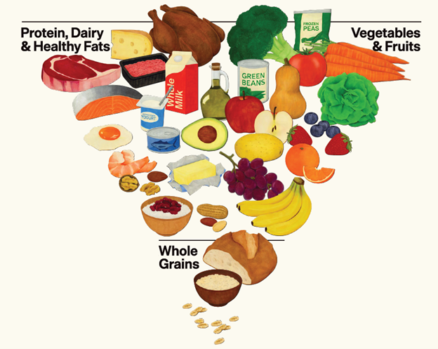

The Banting Diet comes close to meeting the criteria of the ideal real-food diet. (58-60) William Banting (1796-1878), a Victorian undertaker, is regarded as the father of the low-carbohydrate diet. In 1863, Banting wrote a booklet called Letter on Corpulence, Address to the Public, which contained the particular plan for the diet he followed. (58, 60) It was written as an open letter in the form of a personal testimonial. Banting accounted for all his unsuccessful fasts, diets, spas, and exercise regimens in his past. His previously unsuccessful attempts had been on the advice of various medical experts. He then described the dietary change that finally had worked for him, following the advice of another medical expert. “My kind and valued medical adviser is not a doctor for obesity, but stands on the pinnacle of fame in the treatment of another malady, which, as he well knows, is frequently induced by [corpulence].” His own diet consisted of meat, greens, fruits, and dry wine. The emphasis was on avoiding sugar, saccharine matter, starch, beer, and milk. Banting’s pamphlet was popular for years to come and would be used as a model for modern diets.
Figure 3. What real food look like!

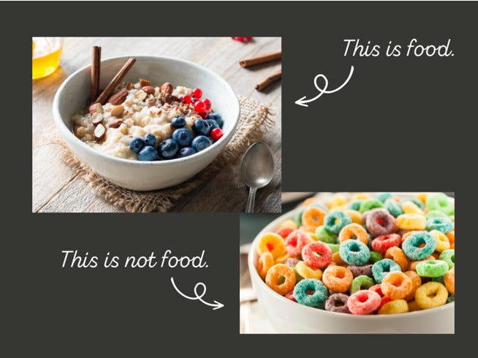

The Banting diet consists mainly of animal protein (including poultry, eggs, and fish), saturated animal fats (including lard, duck fat, and butter), coconut oil, olive oil, and macadamia oil, some cheeses and dairy products, some nuts and seeds, fresh vegetables grown mainly above the ground and a few berries. (59) The Banting diet excludes all processed “food”, pre-packed, boxed, and “food” in wrappers as well as “fast food”. It excludes all foods with sugar, fructose, and maltose as well as grain products (wheat, barley, oats, rye) and soy products. (59) Soy products are genetically modified, toxic non-foods. (59) Replace all seed oils (canola, sunflower, safflower, cottonseed, soy) with healthy saturated fats; extra virgin olive oil and virgin coconut oil are freely encouraged. High-fat dairy products are suggested and not skimmed or fat-free dairy.
A continuous glucose monitor (CGM) is essential for tracking blood glucose levels. Patients should keep detailed records to identify and avoid foods that spike glucose. The target fasting range is 60-80 mg/dL (3.3-4.4 mmol/L), with postprandial (after a meal) glucose remaining under 120 mg/dL (6.6 mmol/L). Ideally, glucose levels should remain flat, with post-meal increases limited to 20 mg/dL.
A blood ketone meter is also recommended to confirm entry into ketosis by measuring β-hydroxybutyrate. Levels below 0.5 mmol/L indicate nonketotic status under normal dietary conditions. Therapeutic ketosis typically requires a blood ketone level above 2 mmol/L, with an optimal range of 3-5 mmol/L. Monitoring changes in both blood glucose and ketones during fasting and physical activity is essential. Therapeutic ketosis is formally defined as a blood glucose level of less than 90 mg/dL, a blood ketone level greater than 2 mmol/L, and a target GKI of less than 2. (44)
The GKI can be calculated at: https://keto-mojo.com/glucose-ketone-index-gki/ and https://perfectketo.com/glucose-ketone-index-calculator/
Insulin Resistance as a Driver of Cancer Progression
Insulin resistance (IR) is not merely a metabolic disorder; it is a biologically active driver of cancer progression. Through hyperinsulinemia, activation of the insulin/IGF-1 axis, chronic inflammation, altered adipokine signaling, and metabolic reprogramming, IR creates a systemic and microenvironmental milieu that promotes tumor growth, invasion, therapeutic resistance, and recurrence.
1. Biological Basis
1.1 Hyperinsulinemia as a Growth Signal
In insulin resistance, peripheral tissues (muscle, liver, adipose) become less responsive to insulin. The pancreas compensates by increasing insulin secretion, resulting in chronic hyperinsulinemia.
Insulin is a potent mitogen. It activates:
- Insulin receptor (IR-A isoform, frequently overexpressed in cancers)
- Insulin-like growth factor-1 receptor (IGF-1R)
These receptors stimulate:
- PI3K → AKT → mTOR pathway
- RAS → RAF → MAPK pathway
Both are central oncogenic signaling cascades that drive:
- Cell proliferation
- Inhibition of apoptosis
- Angiogenesis
- Protein synthesis
- Cell survival
Hyperinsulinemia also reduces hepatic production of IGF-binding proteins, increasing bioavailable IGF-1, further amplifying proliferative signaling.
2. Metabolic Reprogramming
Cancer cells exhibit the Warburg effect (aerobic glycolysis). Insulin resistance contributes by:
- Increasing circulating glucose
- Increasing circulating insulin
- Increasing lipid flux (free fatty acids)
- Enhancing hepatic gluconeogenesis
This metabolic environment:
- Provides abundant fuel for tumor metabolism
- Promotes mitochondrial remodeling
- Supports cancer stem cell survival
High insulin levels also enhance glucose transporter (GLUT) expression, facilitating tumor glucose uptake.
3. Inflammation and the Tumor Microenvironment
Insulin resistance is tightly linked to chronic low-grade inflammation.
Key mediators include:
- TNF-α
- IL-6
- NF-κB activation
- CRP elevation
Adipose tissue in IR becomes infiltrated with pro-inflammatory macrophages, producing cytokines that:
- Promote epithelial–mesenchymal transition (EMT)
- Enhance invasion and metastasis
- Suppress anti-tumor immune responses
Systemic inflammation also contributes to elevated neutrophil-lymphocyte ratio (NLR), which correlates with worse oncologic outcomes.
4. Adipokines and Hormonal Effects
Table 1. Insulin resistance alters adipokine signaling:

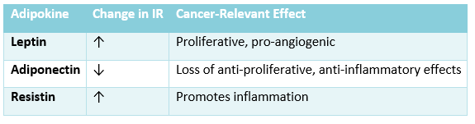

In hormone-sensitive cancers (e.g., breast, endometrial), hyperinsulinemia also:
- Increases aromatase activity
- Decreases sex hormone-binding globulin
- Raises bioavailable estrogen
5. Clinical Evidence Linking IR to Cancer Progression
Insulin resistance and hyperinsulinemia are associated with:
- Increased risk of breast, colorectal, pancreatic, endometrial, liver cancers
- Higher recurrence rates
- Increased cancer-specific mortality
- Reduced response to chemotherapy and immunotherapy
Particularly strong associations exist in:
- Triple-negative breast cancer
- Colorectal cancer
- Hepatocellular carcinoma
Elevated fasting insulin and HOMA-IR correlate with worse survival across multiple malignancies.
6. Therapeutic Implications
Addressing insulin resistance may:
- Reduce proliferative signaling
- Improve immune surveillance
- Enhance response to chemotherapy
- Potentially improve response to immune checkpoint inhibitors
Strategies include:
- Carbohydrate restriction
- Intermittent fasting
- Weight reduction
- Exercise (improves insulin sensitivity independent of weight loss)
- Metformin (AMPK activation, mTOR inhibition)
- GLP-1 receptor agonists (emerging data)

Figure 4. Consequences of insulin resistance

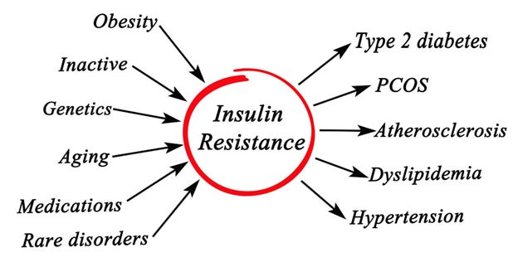

In part 2 of this series I will review what foods you should eat and what foods to avoid. I will also review time restricted eating and fasting.

Subscribe

Share
References
1. Mukherjee P, Sotnokov AV, Mangian HJ, Zhou JR, Visek WJ, Clinton SK. Energy intake and prostate tumor growth, angiogenesis, and vascular endothelial growth factor expression. J. Natl. Cancer Inst. 1999;91:512–23.
2. Mavropoulos JC, Buschemeyer WC, Tewari AK, Rokheld D, Pollak M, Zhao Y. The effects of varying dietary carbohydrate and fat content on survival in a murine LNCap prostate coancer Zenograft model. Cancer Prev. Pre. 2009;2:557–65.
3. Hursting SD, Smith SM, Lashinger LM, Harvey AE, Perkins SN. Calories and carcinogenesis: lessons learnt form 30 years of calorie restriction research. Carcinogenesis. 2010;31:83–9.
4. Kari FW, Dunn SE, French JE, Barrett JC. Roles for insulin-like growth factor-1 in mediating the anti-carcinogenic effects of caloric restriction. J. Nutr. Health Aging. 1999;3:92–101.
5. Bonorden MJ, Rogozina OP, Kluczny CM, Grossmann ME, Grambsch PL, Grande JP, et al. Intermittent calorie restriction delays prostate tumor detection and increases survival time in TRAMP mice. Nutr. Cancer. 2009;61:265–75.
6. Thompson HJ, Jiang W, Zhu Z. Mechanisms by which energy restriction inhibits carcinogenesis. Adv. Exp. Med. Biol. 1999;470:77–84.
7. Zhou W, Mukherjee P, Kiebish MA, Markis WT, Mantis JG, Seyfried TN. The calorically restricted ketogenic diet, an effective alternative therapy for malignant brain cancer. Nutrition & Metabolism. 2007;4:5.
8. Morales-Oyarvide V, Yuan C, Babic A, Zhang S, Niedzwiecki D, Brand-Miller JC, et al. Dietary Insulin Load and Cancer Recurrence and Survival in Patients With Stage III Colon Cancer: Findings From CALGB 89803 (Alliance). J Natl Cancer Inst. 2019;111(2):170–9.
9. Meyerhardt JA, Sato K, Niedzwiecki D, Ye C, Saltz LB, Mayer RJ, et al. Dietary glycemic load and cancer recurrence and survival in patients with stage III colon cancer: findings from CALGB 89803. J Natl Cancer Inst. 2012;104(22):1702–11.
10. Hur J, Otegbeye E, Joh HK, Nimptsch K, Ng K, Ogino S, et al. Sugar-sweetened beverage intake in adulthood and adolescence and risk of early-onset colorectal cancer among women. Gut. 2021;70(12):2330–6.
11. Hodge AM, Bassett JK, Milne RL, English DR, Giles GG. Consumption of sugar-sweetened and artificially sweetened soft drinks and risk of obesity-related cancers. Public Health Nutr. 2018;21(9):1618–26.
12. Laguna JC, Alegret M, Cofán M, Sánchez-Tainta A, Díaz-López A, Martínez-González MA, et al. Simple sugar intake and cancer incidence, cancer mortality and all-cause mortality: A cohort study from the PREDIMED trial. Clin Nutr. 2021;40(10):5269–77.
13. Goncalves MD, Lu C, Tutnauer J, Hartman TE, Hwang SK, Murphy CJ, et al. High-fructose corn syrup enhances intestinal tumor growth in mice. Science. 2019;363(6433):1345–9.
14. Jiang Y, Pan Y, Rhea PR, Tan L, Gagea M, Cohen L, et al. A Sucrose-Enriched Diet Promotes Tumorigenesis in Mammary Gland in Part through the 12-Lipoxygenase Pathway. Cancer Res. 2016;76(1):24–9.
15. Debras C, Chazelas E, Srour B, Kesse-Guyot E, Julia C, Zelek L, et al. Total and added sugar intakes, sugar types, and cancer risk: results from the prospective NutriNet-Santé cohort. Am J Clin Nutr. 2020;112(5):1267–79.
16. Feng T, Luo Q, Liu Y, Jin Z, Skwarchuk D, Lee R, et al. Fructose and glucose from sugary drinks enhance colorectal cancer metastasis via SORD. Nat Metab. 2025.
17. Warburg O, Wind F, Negelein E. The metabolism of tumors in the body. J. Gen. Physiol. 1927;6:519–30.
18. Warburg O. On the origin of cancer cells. Science. 1956;123:309.
19. McGirt MJ, Chaichana KL, Gathinji M, Attenello F, Than K, Ruiz AJ, et al. Persistent outpatient hyperglycemia is independently associated with decreased survival after primary resection of malignant brain astrocytomas. Neurosurgery. 2008;63:286–91.
20. Meynet O, Ricci JE. Caloric restriction and cancer: molecular mechanisms and clinical implications. Trends in Molecular Medicine. 2014;20:419–27.
21. Godsland IF. Insulin resistance and hyperinsulinaemia in the development and progression of cancer. Clin Sci (Lond). 2009;118(5):315–32.
22. Currie CJ, Poole CD, Gale EA. The influence of glucose-lowering therapies on cancer risk in type 2 diabetes. Diabetologia. 2009;52(9):1766–77.
23. Wilder RM. The effects of ketonemia on the course of episepsy. Mayo Clin Proc. 1921;2:307–8.
24. Weber DD, Aminzadeh-Gohari S, Tulipan J, Catalano L, Feichtinger RG, Kofler B. Ketogenic diet in the treatment of cancer - Where do we stand? Mol Metab. 2020;33:102–21.
25. Lewis NE, Abdel-Haleem AM. The evolution of genome-scale models of cancer metabolism. Front Physiol. 2013;4:237.
26. Weber DD, Aminzadeh-Gohari S, Thapa M, Redtenbacher AS, Catalano L, Capelôa T, et al. Ketogenic diets slow melanoma growth in vivo regardless of tumor genetics and metabolic plasticity. Cancer Metab. 2022;10(1):12.
27. Woolf EC, Syed N, Scheck AC. Tumor Metabolism, the Ketogenic Diet and β-Hydroxybutyrate: Novel Approaches to Adjuvant Brain Tumor Therapy. Front Mol Neurosci. 2016;9:122.
28. Woolf EC, Curley KL, Liu Q, Turner GH, Charlton JA, Preul MC, et al. The Ketogenic Diet Alters the Hypoxic Response and Affects Expression of Proteins Associated with Angiogenesis, Invasive Potential and Vascular Permeability in a Mouse Glioma Model. PLoS One. 2015;10(6):e0130357.
29. Lussier DM, Woolf EC, Johnson JL, Brooks KS, Blattman JN, Scheck AC. Enhanced immunity in a mouse model of malignant glioma is mediated by a therapeutic ketogenic diet. BMC Cancer. 2016;16:310.
30. Li J, Zhang H, Dai Z. Cancer Treatment With the Ketogenic Diet: A Systematic Review and Meta-analysis of Animal Studies. Front Nutr. 2021;8:594408.
31. Abdelwahab MG, Fenton KE, Preul MC, Rho JM, Lynch A, Stafford P, et al. The ketogenic diet is an effective adjuvant to radiation therapy for the treatment of malignant glioma. PLoS One. 2012;7(5):e36197.
32. Puchalska P, Crawford PA. Multi-dimensional roles of ketone bodies to fuel metabolism, signaling, and therapeutics. Cell Metabolism. 2017;25:262–84.
33. Hwang CY, Choe W, Yoon KS, Ha J, Kim SS, Yeo EJ, et al. Molecular mechanisms for ketone body metabolism, signaling functions, and therapeutic potential in cancer. Nutrients. 2022;14:4932.
34. Newman JC, Verdin E. Ketone bodies as signaling metabolites. Trends in Endocrinology and Metabolism. 2014;25:42–52.
35. Shimazu T, Hirschey MD, Newman J, He W, Shirakawa K, Le Moan N, et al. Suppression of oxidative stress by B-hydroxybutyrate, and endogenous histone deacetylase inhibitor. Science. 2013;339:211–4.
36. Mulrooney TJ, Marsh J, Urits I, Seyfried TN, Mukherjee P. Influence of caloric restriction on constitutive expression of NFkB in an experimental mouse astrocytoma. PloS ONE. 2011;6(3):e18085.
37. Chi JT, Lin PH, Tolstikov V, Howard L, Chen EY, Bussberg V, et al. Serum metabolomic analysis of men on a low-carbohydrate diet for biochemically recurrent prostate cancer reveals the potential role of ketogenesis to slow tumor growth: a secondary analysis of the CAPS2 diet trial. Prostate Cancer Prostatic. Dis. 2022;25(4):770–7.
38. Freedland SJ, Allen J, Jarman A, Oyekunle T, Armstrong AJ, Moul JW, et al. A Randomized Controlled Trial of a 6-Month Low-Carbohydrate Intervention on Disease Progression in Men with Recurrent Prostate Cancer: Carbohydrate and Prostate Study 2 (CAPS2). Clin Cancer Res. 2020;26(12):3035–43.
39. Cohen CW, Fontaine KR, Arend RC, Soleymani T, Gower BA. Favorable Effects of a Ketogenic Diet on Physical Function, Perceived Energy, and Food Cravings in Women with Ovarian or Endometrial Cancer: A Randomized, Controlled Trial. Nutrients. 2018;10(9).
40. Cohen CW, Fontaine KR, Arend RC, Alvarez RD, Leath CA, III, Huh WK, et al. A Ketogenic Diet Reduces Central Obesity and Serum Insulin in Women with Ovarian or Endometrial Cancer. J Nutr. 2018;148(8):1253–60.
41. Khodabakhshi A, Akbari ME, Mirzaei HR, Mehrad-Majd H, Kalamian M, Davoodi SH. Feasibility, Safety, and Beneficial Effects of MCT-Based Ketogenic Diet for Breast Cancer Treatment: A Randomized Controlled Trial Study. Nutr Cancer. 2020;72(4):627–34.
42. Evangeliou AE, Spilioti MG, Vassilakou D, Goutsaridou F, Seyfried TN. Restricted Ketogenic Diet Therapy for Primary Lung Cancer With Metastasis to the Brain: A Case Report. Cureus. 2022;14(8):e27603.
43. Seyfried TN, Shivane AG, Kalamian M, Maroon JC, Mukherjee P, Zuccoli G. Ketogenic Metabolic Therapy, Without Chemo or Radiation, for the Long-Term Management of IDH1-Mutant Glioblastoma: An 80-Month Follow-Up Case Report. Front Nutr. 2021;8:682243.
44. Meidenbauer JJ, Mukherjee P, Seyfried TN. The glucose ketone index calculator: a simple tool to monitor therapeutic efficacy for metabolic management of brain cancer. Nutr. Metab (Lond). 2015;12:12.
45. Augustin K, Khabbush A, Williams S, Eaton S, Orford M, Cross JH, et al. Mechanisms of action for the medium-chain triglyceride ketogenic diet in neurological and metabolic disorders. Lancet Neurol. 2018;17(1):84–93.
46. Shukla SK, Gebregiworgis T, Purohit V, Chaika NV, Gunda V, Radhakrishnan P, et al. Metabolic reprogramming induced by ketone bodies diminishes pancreatic cancer cachexia. Cancer Metab. 2014;2:18.
47. Li XX, Liu C, Dong SL, Ou CS, Lu JL, Ye JH. Anticarcinogenic potentials of tea catechins. Front. Nutr. 2022;9:1060783.
48. Miyata Y, Shida Y, Hakariya T, Sakai H. Anti-cancer effects of green tea polyphenols against prostate cancer. Molecules. 2019;24:193.
49. Yang C, Sudderth J, Dang T, Bachoo RG, McDonald JG, Deberardinis RJ. Glioblastoma cells require glutamate dehydrogenase to survive impairements of glucose metabolism or Akt signaling. Cancer Res. 2009;69:7986–93.
50. Li M, Li C, Allen A, Stanley CA, Smith TJ. The structure and allosteric regulaion of mammalian glutamate dehydrogenase. Arch. Biochem. Biophys. 2012;519:69–80.
51. Li C, Allen A, Kwagh J, Doliba NM, Qin W, Najafi H, et al. Green tea polyphenols modulate insulin secretion by inhibiting glutamate dehydrogenase. J. BIol. Chem. 2006;281:10214–21.
52. Bettuzzi S, Brausi M, Rizzi F, Castagnetti G, Peracchia G, Corti A. Chemoprevention of human prostate cancer by oral administration of green tea catechins in volunteers with high-grade prostate intraepithelial neoplasia: A preliminary report from a one-year proof-of-principle study. Cancer Res. 2006;66:1234–40.
53. Hope JR. Surviving Cancer, COVID-19 & Disease. The repurposed drug revolution. Redding, CA: Hope Pressworks International; 2020.
54. Mukherjee P, Greenwood B, Henao J, Kiebish MA, Seyfried TN. Ketogenic diet as a metabolic vehicle for enhancing the therapeutic efficacy of mebendazole and devimistat in preclinical pediatric glioma. bioRxiv. 2023.
55. Ifland J, Marcus MT, Preuss HG. Processed Food Addiction. Foundations, Assessment, and Recovery. Boca Rotan, FL: CRC Press; 2018.
56. Fiolet T, Srour B, Sellem L, Kesse-Guyot E, Allès B, Méjean C, et al. Consumption of ultra-processed foods and cancer risk: results from NutriNet-Santé prospective cohort. Bmj. 2018;360:k322.
57. Kliemann N, Rauber F, Bertazzi Levy R, Viallon V, Vamos EP, Cordova R, et al. Food processing and cancer risk in Europe: results from the prospective EPIC cohort study. Lancet Planet Health. 2023;7(3):e219–e32.
58. Banting W. Letter on Corpulence, Addressed to the Public. 3rd ed. London, UK: Harrison; 1864.
59. Creed SA. The Real Meal Revolution. The Radical, Sustainable Approach to Healthy Eating. London, UK: Robinson; 2015.
60. Meadows W. The Banting Diet: Letter on Corpulence: FCD Publising; 2015.
2017;390:2050–62.

Subscribe to Paul Marik

